DOCUMENTATION OF CREATION OF VOLUMES IN DOCKER BY SRINIVAS.P

To create volumes in a docker there are 3 ways we:

1) Using the Dockerfile.

2) Create a volume will create a container using command.

3) Creating a local volume and mount it to the container.

1. using the Dockerfile: To create a volume using a Dockerfile is a method in which we create Dockerfile and build it as an image using that image creating a container, In the Dockerfile using components we can create a volume always remember that in Dockerfile starting letter ‘d’ will be always upper case.
2. FROM: it is main component in Dockerfile using this only the image will be built VOLUME: it is component that is used to create a volume will create a container after this component the name of the container will be provide in [“/\*”] place of star After creating this file execute this command to build the image using that file docker build -t img .
3. Now create container using the newly created image by execute this command docker run -itd –name cont -p 80:80 img
4. now go in to the container using exit command and go to root directory there use the command ‘ls’ you will see the created volume as a directory as shown in the below image

Create a volume will create a container using commands:

In this method we use a simple command to create a volume using any of the required base image.

After creating container and migrating the data container to container.

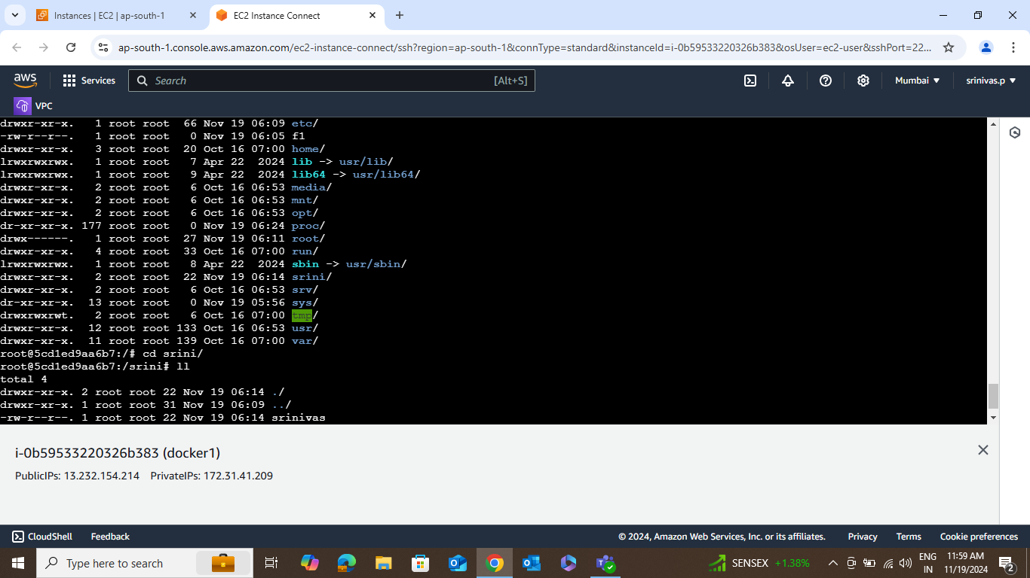

Here creating the multiple docker files via vim command.

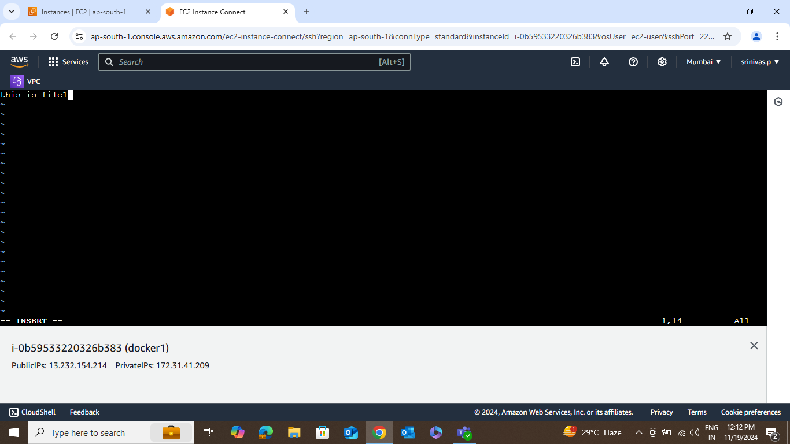

After creating the containers list we will get the list of existing container – using the command [docker ps -a]

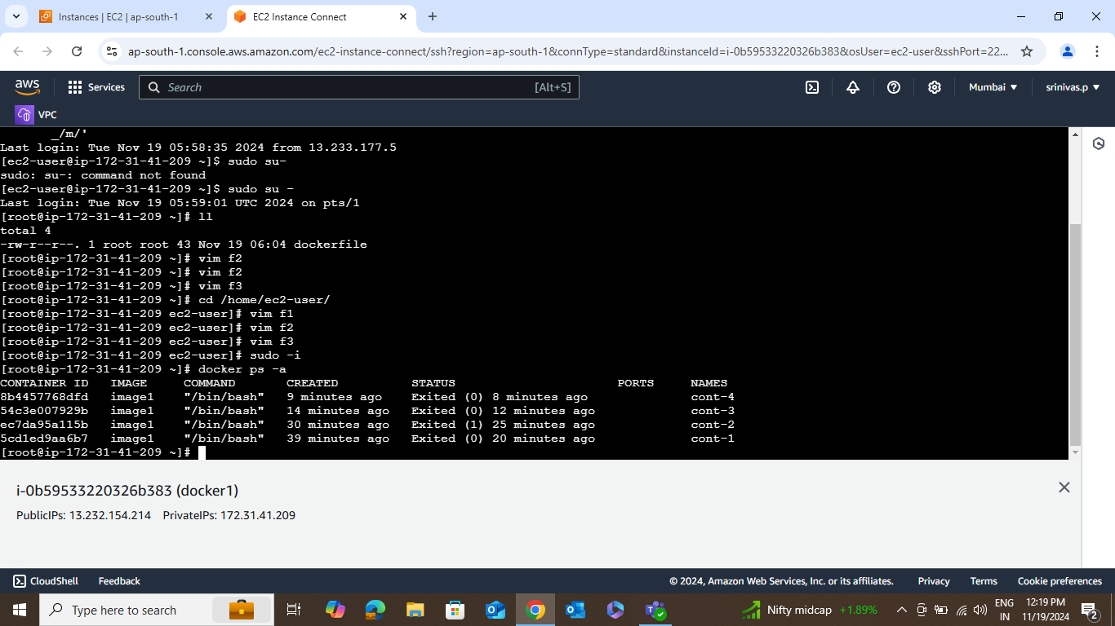

Finally we get the list of volumes using the command [docker volume ls]

